NAMA : Andi Wicaksono Nugroho

NIM : E41201570

SS Output :

1. Home

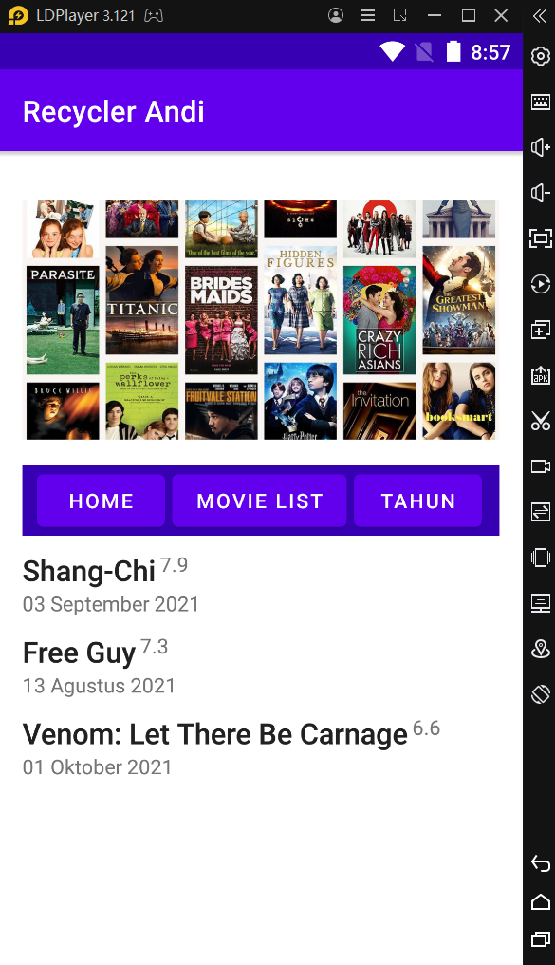

1. Clicked

